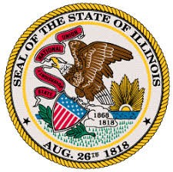

OFFICE OF THE LIEUTENANT GOVERNOR
JULIANA STRATTON—LIEUTENANT GOVERNOR

RESTORE, REINVEST, AND RENEW PROGRAM BOARD
SFY2023 R3 Notice of Funding Opportunity (NOFO) Workgroup
Regular Meeting
Pursuant to § 10-40 of the Cannabis Regulation and Tax Act (410 ILCS 705/)

Date and Time
Thursday, September 23, 2021
10:00AM–11:00AM

Location
Videoconference/Teleconference

Dial-In Information
Videoconference | Teleconference
Videoconference information will be shared  with Workgroup members separately. | Phone Number: (312) 535-8110
 | Access Code: 2468 047 0278

Agenda

- Call to Order and Roll Call
- Approval of the Agenda for 09/23/2021
- New Business
  - Discuss eligibility of capacity building grants and/or corresponding processes for potential recommendations
- Member Updates
- Public Comments
- Adjournment
  - Next meeting: Wednesday, September 29, 2021 from 12:00PM—1:30PM

