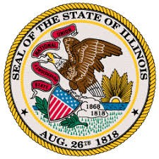

OFFICE OF THE LIEUTENANT GOVERNOR
JULIANA STRATTON—LIEUTENANT GOVERNOR

RESTORE, REINVEST, AND RENEW PROGRAM BOARD
SFY2023 R3 Notice of Funding Opportunity (NOFO) Workgroup
Regular Meeting
Pursuant to § 10-40 of the Cannabis Regulation and Tax Act (410 ILCS 705/)

Date and Time
Friday, October 1, 2021
9:30AM—11:00AM

Location
Videoconference/Teleconference

Dial-In Information
Videoconference | Teleconference
Videoconference information will be shared  with Workgroup members separately. | Phone Number: (312)535-8110
 | Access Code: 2462 808 2266

Agenda

- Call to Order and Roll Call
- Approval of the Agenda 10/1/2021
- New Business
  - Discuss overall scoring categories and weights and/or corresponding processes for potential recommendations
- Member Updates
- Public Comments
- Adjournment
  - Next meeting: Wednesday, October 6, 2021 from 12:00PM—1:30PM

