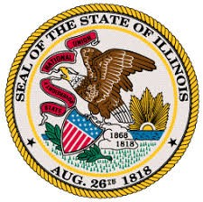

OFFICE OF THE LIEUTENANT GOVERNOR
JULIANA STRATTON—LIEUTENANT GOVERNOR

RESTORE, REINVEST, AND RENEW PROGRAM BOARD
SFY2023 R3 Notice of Funding Opportunity (NOFO) Workgroup
Regular Meeting
Pursuant to § 10-40 of the Cannabis Regulation and Tax Act (410 ILCS 705/)

Date and Time
Wednesday, October 6, 2021
12:00PM–1:30PM

Location
Videoconference/Teleconference

Dial-In Information
Videoconference | Teleconference
Videoconference information will be shared  with Workgroup members separately. | Phone Number: (312) 535-8110
 | Access Code: 2451 435 0082

Agenda

- Call to Order and Roll Call
- Approval of the Agenda 10/6/2021 and Minutes for 9/29/2021 and 10/1/2021
- Old Business
  - Follow-up discussion on equity scoring criteria, overall scoring, and weights
- New Business
  - Discuss collaborative applications and/or corresponding processes for potential recommendations
- Member Updates
- Public Comments
- Adjournment
  - Remaining meetings:
    - Tuesday, October 12, 2021 from 10:00AM—12:00PM
    - Wednesday, October 13, 2021 from 12:00PM to 1:30PM

