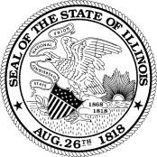
ILLINOIS

CRIMINAL JUSTICE

INFORMATION AUTHORITY

300 W. Adams Street • Suite 200 • Chicago, Illinois 60606 • (312) 793-8550

Regular Board Meeting Thursday, March 17, 2022
10:00 a.m. to 12:00 p.m.
Illinois Criminal Justice Information Authority

Location:
Via Webex Video Conference/Teleconference

Participation Information:
Videoconference | Teleconference
Link available to Board Members only via separate calendar invite | Conference Phone Number: 415-655-0002
Access Code:
2469 648 2738

- Chairperson’s Remarks
- Approval of Minutes
  - January 21,2021
  - March 18, 2021
  - June 24, 2021
  - September 16, 2021

- Executive Director’s Remarks
- Board Attendance/Membership
- Executive Staff Update – Assistant Deputy Director Aditi Singh
- CESF (Corona Emergency Supplemental Fund) Update – FSGU Director Greg Stevens
- Public Comment
- Adjourn

