ARI SFY22 Expansion Grants Notice of Funding Opportunity
Questions & Answers

Round 1:
7/21/2021

Does the individual being helped have to have been imprisoned or have a criminal record?

To be served by an ARI-funded prison diversion program, the individual must be convicted of an offense that could carry a prison term (felony) but that is probation-eligible. Prior incarceration or justice involvement (to the current charge) are not required for eligibility.
Can it just people individuals going down the wrong path and the agencies are trying to stop them from doing so?
See above. Program participants would be expected to be facing a prison sentence “but for ARI.” Many sites consider ARI-funded interventions as the last chance to remain in the community before prison.
Is there a focus of children teens or adults?
Adult Redeploy Illinois funds programs that serve justice-involved adults. There is a juvenile Redeploy Illinois program that operates out of the Illinois Department of Human Services.
Can you use the fund to improve a current program that is working but need the funds to expand it?
Yes, ARI funds can be used to expand or enhance existing prison diversion programs.
When you say "specialized" population, what do you mean by that? Can it be all folks who are struggling in the community??
“Specialized” populations can be defined by the applicant and generally refer to specific, identifiable groups (e.g., emerging adults, women) based on assessed risk, needs, and/or strengths.

7/23/2021

If a circuit has a few counties that want to apply for the expansion grant, do they need to all apply together under one jurisdiction like the current grant or can it be separate entities?

Any county level unit of government is eligible and can apply, either singly or on behalf of a group of counties or entire judicial circuit.

Round 2
7/27/2021

Since the grant is subject to start on October 1, 2021, and conclude on June 31, 2022 (8 months), would the current budget for the grant application need to be for just that eight (8) month period or completed for a normal 12 months?

The budget that would be submitted with the application should cover the nine (9) month grant period, October 1, 2021 through June 30, 2022 (for expenses anticipated in October, November, December, January, February, March, April, May, and June).

7/29/2021

In reviewing the grant instructions it states that the "solicitation is open to county units of government or judicial circuits. A county may submit on behalf of a group of counties or a judicial circuit. Other unit of local government, private agencies, or not-for-profit organizations are not eligible to apply..." Can a county health department act as the implementing agency (fiscal agent), with probation acting as the program agency?

Yes, this solicitation is open to county units of government or judicial circuits. A county may submit on behalf of a group of counties or a judicial circuit. Other units of local government, private agencies or not-for-profit organizations are not eligible to apply; however, the applicant jurisdiction may include subawards or subcontracts for services with these entities as part of the program design and budget.

8/3/2021

We are not a county unit of government or a judicial circuits. Are we eligible as a 501( c) 3 ?

As noted on page 17 of the NOFO instructions, under “Eligible Applicants”:
This solicitation is open to county units of government or judicial circuits. A county may submit on behalf of a group of counties or a judicial circuit. Other units of local government, private agencies or not-for-profit organizations are not eligible to apply; however, the applicant jurisdiction may include subawards or subcontracts for services with these entities as part of the program design and budget (see Section D, 6h).

If we can apply do we need to reply to track 1,2 and 3 or can we just apply for only 1 of these tracks?

Applicants can choose one or more Tracks to apply to; however, separate application packets are required for each Track.

8/5/2021

I am working with an organization that is attempting to submit a notice of intent, and I have a couple of questions. Does our application need to be in conjunction with an existing prison diversion program? Or will this funding opportunity support community-based programs outside of a existing prison diversion program?

No, applications do not have to be in conjunction with an existing program but can be used to create new programs. However, only county units of government are eligible to submit applications, which can (and are encouraged to) include partnerships with community-based not-for-profit organizations. As noted on page 4 of the NOFO instructions, under “Purpose”:

The purpose of this funding opportunity is to expand ARI through grants to local jurisdictions for planning, implementation, and pilot projects that address gaps in service and/or the needs of specialized populations, with the overall goal to reduce the number of people committed to prison on probation-eligible charges. ARI funds can be used to create or enhance local programs that assess individuals’ risk, needs, and strengths and offer a continuum of evidence-based sanctions and treatment alternatives to incarceration focused on rehabilitation and accountability over punishment.

Regarding eligibility, as noted on page 17 of the NOFO instructions, under “Eligible Applicants”:

This solicitation is open to county units of government or judicial circuits. A county may submit on behalf of a group of counties or a judicial circuit. Other units of local government, private agencies or not-for-profit organizations are not eligible to apply; however, the applicant jurisdiction may include subawards or subcontracts for services with these entities as part of the program design and budget (see Section D, 6h).

Notice of Intent: The link on your page is sending up this message. Please advise on how to proceed.

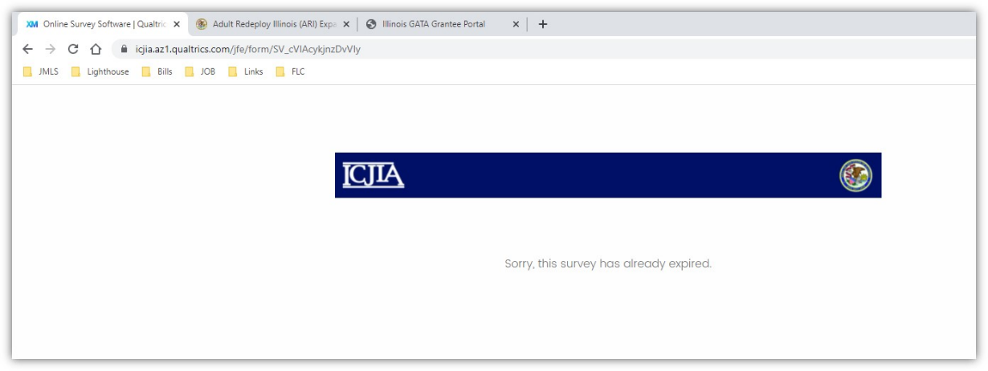

The Notice of Intent link has been fixed; please try again.

